**PROBLEM – 2** List the name, department, phone number, and email address of employees with a phone number beginning with “3-”.

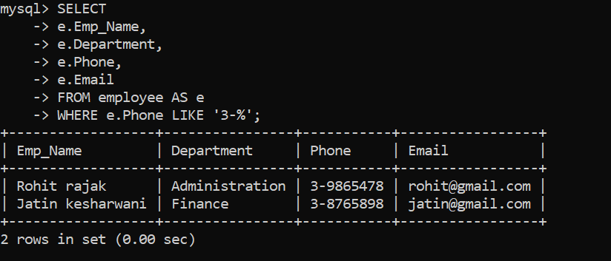

**SELECT**

**-> e.Emp_Name,**

**-> e.Department,**

**-> e.Phone,**

**-> e.Email**

**-> FROM employee AS e**

**-> WHERE e.Phone LIKE '3-%';**